DFIR MADNESS  
Forensics Report and Documentation

THE CASE OF THE STOLEN SZECHUAN SAUCE



**Submitted By: Sukhvir Sahota**

Table of Contents

**Contributors and Responsibilities** **2**

**Executive Summary** **3**

**Introduction** **3**

**Evidence Collection and Analysis** **4**

**Analysis** **5**

Question 1: What’s the Operating System of the Server? 5

Question 2: What’s the Operating System of the Desktop? 6

Question 3: What was the local time of the Server? 6

Question 4: Was there a breach? 7

Question 5: What was the initial entry vector (how did they get in)? 7

Question 6: Was malware used? If there was malware answer the following… 9

6.a. What process was malicious? 9

6. b What was the IP that delivered the payload? 12

6. c. What IP Address is the malware calling to? 13

6. c. Where is this malware on disk? 15

6.d. When did it first appear? 15

6.e. Did someone move it? 16

6. f. What were the capabilities of this malware? 17

6. g. Is this malware easily obtained? 18

6. h. Was this malware installed with persistence on any machine? 18

When? 18

Where? 19

Question 7: What malicious IP Addresses were involved? 20

7. a. Were any IP Addresses from known adversary infrastructure? 20

7. b. Are these pieces of adversary infrastructure involved in other attacks around the time of the attack? 20

Question 8: Did the attacker access any other systems? How? When? 21

8.b. Did the attacker steal or access any data? 22

Question 9: What was the network layout of the victim network? 24

**Bonus Questions** **26**

What architectural changes should be made immediately? 26

Did the attacker steal the Szechuan sauce? If so, what time? 26

Did the attacker steal or access any other sensitive files? If so, what times? 26

**Conclusion** **28**

**References** **29**

# Contributors and Responsibilities

This investigation was conducted collaboratively, with specific tasks divided between team members to ensure thorough and efficient analysis. The responsibilities were distributed as follows:

**My Contributions to Analysis:**

* Analyzed Desktop Disk Image (E01), via Autopsy and FTK Imager
* Examined memory images from both server and desktop.
* Examine PCAP files.
* Investigated Autoruns.
* Investigated the hives and logs on Register Explorer and Even logs.

**My Partner’s Contribution to Analysis:**

* Analyzed Disk Images (DC01 Disk Image (EO1), via Autopsy and FTK Imager.
* Examine PCAP files.
* Investigated Autoruns.
* Investigated the hives and logs on Register Explorer and Even logs.

**Team contribution:**

* Verified the malicious IP addresses and their connections to known adversary infrastructure via external tools like VirusTotal.
* Reviewed our findings together to see the relation between both Server and Desktop data.

# Executive Summary

In the digital age, the realm of cybersecurity is continuously evolving to combat the increasing complexity and frequency of cyber attacks. Amidst this landscape, cyber forensics has emerged as an indispensable discipline, playing a critical role in understanding and mitigating security incidents. Cyber forensics involves the application of scientific methods to collect, process, and interpret electronic data for the purpose of preserving evidence and uncovering the truth about cyber incidents.

In the "Case of the Stolen Szechuan Sauce," our cyber forensics investigation revealed a breach facilitated by a brute force attack on **Remote Desktop Protocol (RDP)** using stolen credentials. Advanced tools like FTK Imager, Autopsy, Volatility, and Wireshark were utilized to analyze Disk Images, memory images, PCAP files, and Autoruns from both server and desktop systems.

The server was identified as Windows Server 2012 R2 and the desktop as Windows 10 Enterprise. The malicious process, **coreupdater.exe**, was found on both systems, delivered via IP **194.61.24.102** and calling back to IP **203.78.103.109**. This malware, linked to **Metasploit**, enabled data exfiltration, remote control, and other malicious activities. The attacker exfiltrated sensitive files, including the Szechuan sauce recipe, and accessed the network's Desktop machine through the Domain Controller. To prevent future breaches, it's recommended to immediately remove external RDP access to the Domain Controller, limiting it to local network users only.

The attacker successfully stole the Szechuan sauce recipe and accessed other sensitive files. Immediate removal of external RDP access to the Domain Controller was recommended. By implementing these measures, the organization can significantly enhance its security posture, mitigate the risk of future breaches, and protect sensitive information from cyber threats.

# Introduction

Cyber Forensics also known as computer forensics is an investigation of computers. It is a branch of technology that provides methods of investigation to find and preserve evidence from computers. It is often helpful in discovering evidence and especially in helpful cybercrime.

In this report, we will discuss the “Case of the Stolen Szechuan Sauce” which focuses on analyzing a breach by employing advanced tools and methodologies. We had our investigation on the Disk Images, memory images, PCAP files, and Autoruns from both server and desktop.

**Challenge Overview**



Full details of the challenge can be found [here](https://dfirmadness.com/the-stolen-szechuan-sauce/).

# Evidence Collection and Analysis

The evidence files are downloaded from [Dfirmadness.com](http://dfirmadness.com) and credit for that goes to *James Smith* and his team, they did a wonderful job with evidence collection.

The following evidence files were used in our investigation:

* DC01 Disk Image (EO1)
* DC01 Memory and PageFile
* DC01 Autoruns
* Case001 PCAP
* Desktop Disk Image (E01)
* Desktop Memory and PageFile
* Desktop Autoruns

| **Note:** All the required files were already available on Windows 1 of the EVE environment so we did not perform the hash crosscheck activity if the files were downloaded directly from the website then it is recommended to check the integrity of the downloaded file as a best security practice. |
| --- |

We had our investigation on the Disk Images, memory images, PCAP files, and Autoruns from both server and desktop.

**Tools Used**

* [FTK Imager](https://www.exterro.com/digital-forensics-software/ftk-imager)
* [Autopsy](https://www.autopsy.com/)
* [Registry Explorer](https://ericzimmerman.github.io/#!index.md)
* [Volatility](https://volatilityfoundation.org/) via command line and Volatility Workbench
* [Wireshark](https://www.wireshark.org/)
* [RegRipper](https://www.forensicfocus.com/articles/a-guide-to-regripper-and-the-art-of-timeline-building/)
* [EvenViewer](https://learn.microsoft.com/en-us/shows/inside/event-viewer)
* Other online tools to check hashes and IPs: are [Shodan](https://www.shodan.io/) and [VirusTotal](https://www.virustotal.com/).

# Analysis

## Question 1: What’s the Operating System of the Server?

**Answer: Windows Server 2012 R2 Standard Evaluation**

**Autopsy**

Using the Autopsy analysis tool for the DC01-EC01 data folder we got the Operating System of the server as ***Windows Server 2012 R2 Standard Evaluation***.

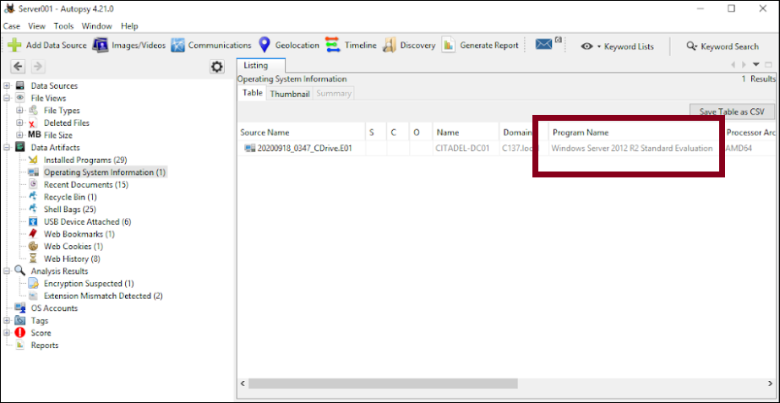

## Question 2: What’s the Operating System of the Desktop?

**Answer: Windows 10 Enterprise Evaluation**.

**Autopsy**

Following the same idea as from question 1, by using the Autopsy analysis tool for the Desktop Disk Image (E01) data folder we got the Operating System of the server as ***Windows 10 Enterprise Evaluation***.

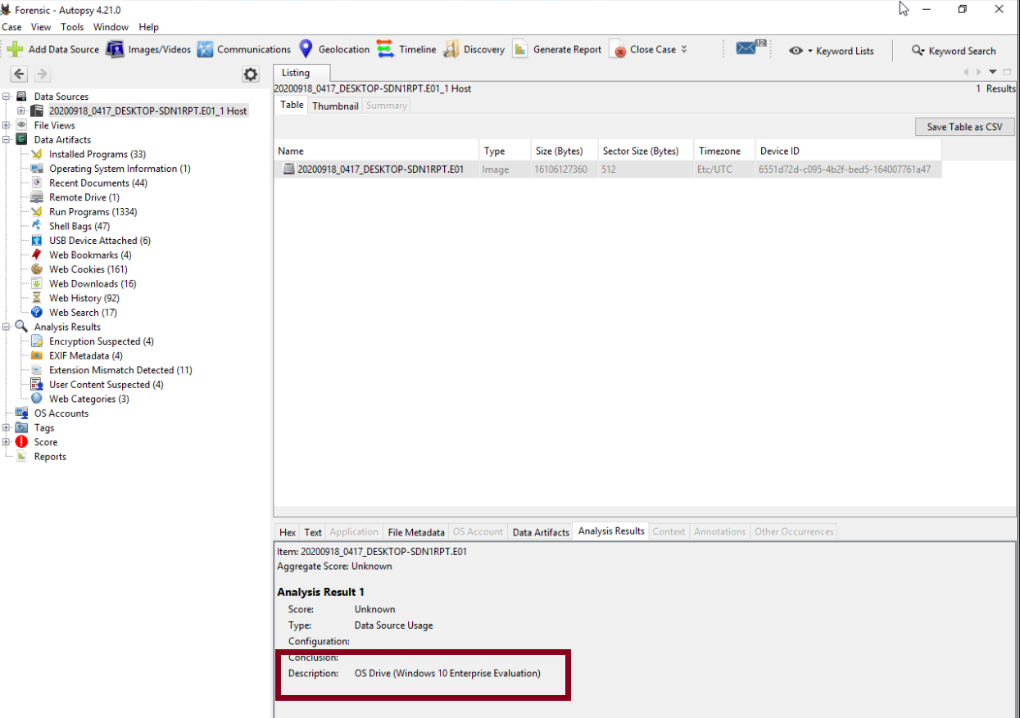

## Question 3: What was the local time of the Server?

**Answer: Pacific Standard Time (PST)**

**Registry Explorer**

* To find this information, we extracted the ***System and Software hives*** from the DC01 Disk Image (EO1) and Desktop Disk Image (E01).
  + **Windows/System32/config**
* Then, I imported them into the ***Registry Explorer tool***, then searched for TimeZone information.

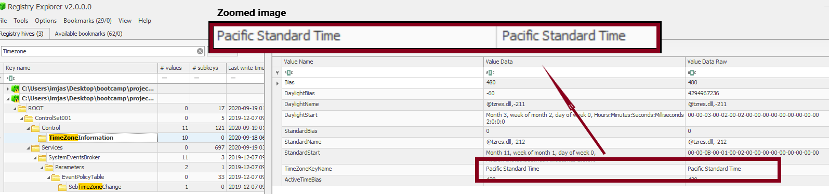

## Question 4: Was there a breach?

**Answer: Yes**

Our next questions will give more information about how the breach happened.

## Question 5: What was the initial entry vector (how did they get in)?

**Answer:** **The initial entry vector was through a successful Remote Desktop Protocol (RDP) logon using stolen credentials (Brute force).**

**Even Viewer**

* To prove that, first I looked into ***Security logs*** in ***Event Viewer*** for forced entry or indication of stolen credentials. Upon investigation, it was clear that multiple failed attempts were made. In the screenshot below,
  + Event ID 4625 - indicated wrong credentials,
  + Event ID 4624 - which indicates the success of the login

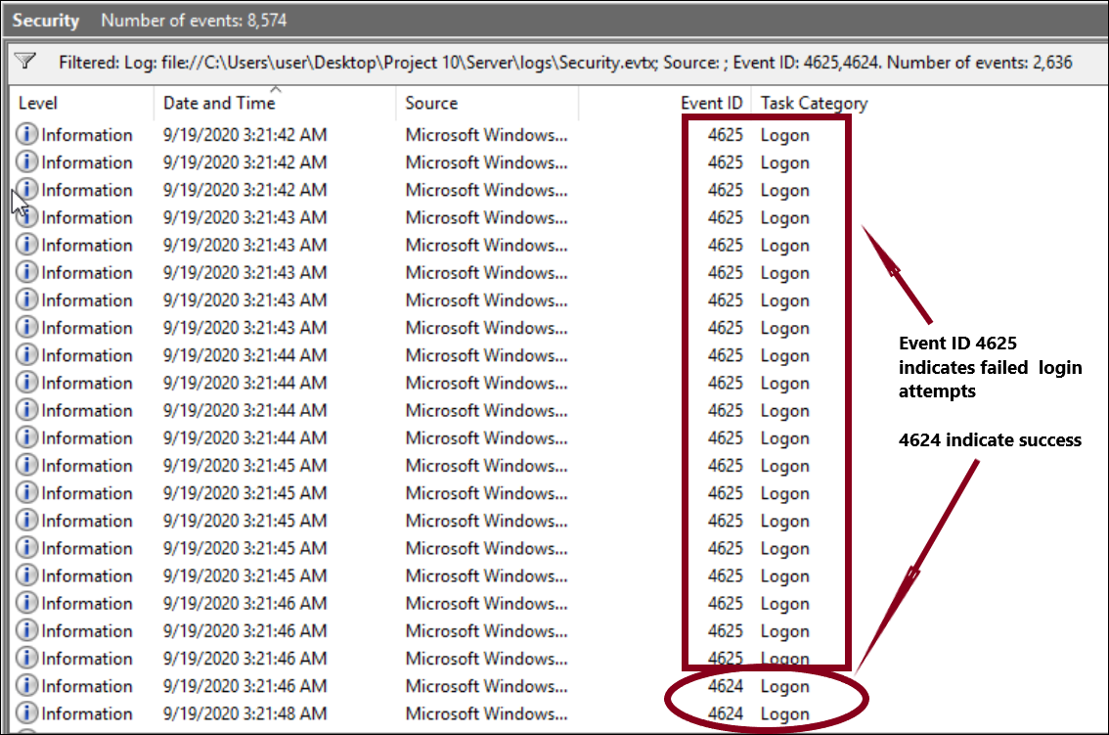

**Wireshark Capture**

* To further investigate, let's look into Wireshark***, RDP Brute Force*** was employed initially due to the numerous SYN requests directed at the same destination port.
  + There are numerous TCP connections initiated on port ***3389***, which is the default port for RDP. For example, packets with ***Source Port 38088, 38089, 38090***, etc., all connect to ***Destination Port 3389***. These frequent attempts are a hallmark of brute force attacks, where an attacker repeatedly tries to connect to the RDP service with different credentials.
  + Many ***SYN*** packets (initial connection requests) and ***SYN-ACK*** responses. For example, packets ***84320, 84321,*** and ***84322*** are part of a connection handshake. This repeated sequence indicates numerous attempts to establish connections.
  + The source ports change in each attempt (***38088, 38089, 38090***, etc.), which is typical in brute force attacks to avoid detection and logging mechanisms that might flag repeated attempts from the same source port.
  + Packets ***8436***3 and ***84364*** show RDP-related traffic, specifically RDP negotiation requests. The repeated presence of RDP negotiation attempts suggests multiple connection attempts.

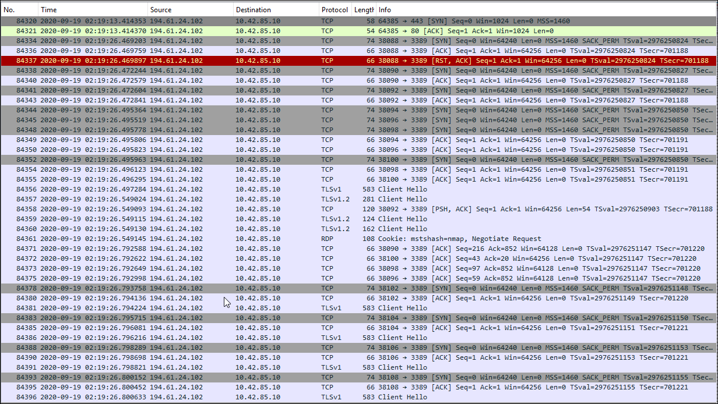

## Question 6: Was malware used? If there was malware answer the following…

### **6.a. What process was malicious?**

**Answer: *coreupdater.exe***

**From Autopsy**

* Extract ***Amcache.hve*** from ***Windows/appcompat/Progams***.

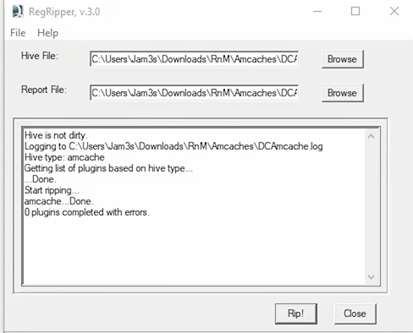

* Open ***Amcache.hve*** files in **RegRipper** to generate a report.

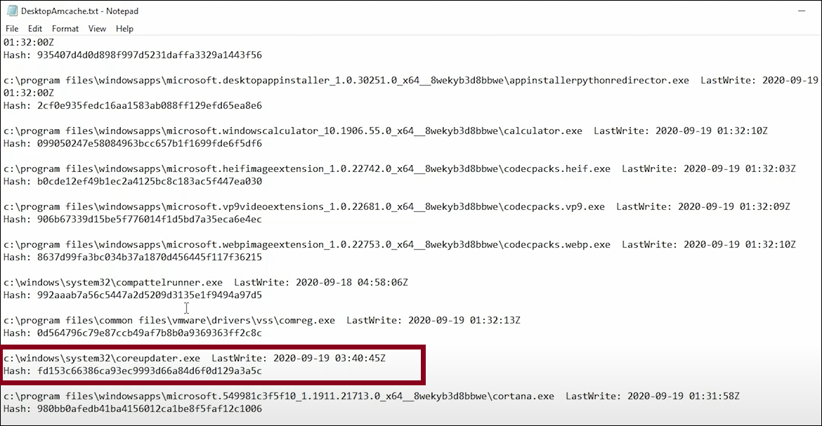

* Check the Hash value of each file you are not aware of, I did manually check the hash of all files and found Coreupdater.exe was marred suspicious by 61 vendors.

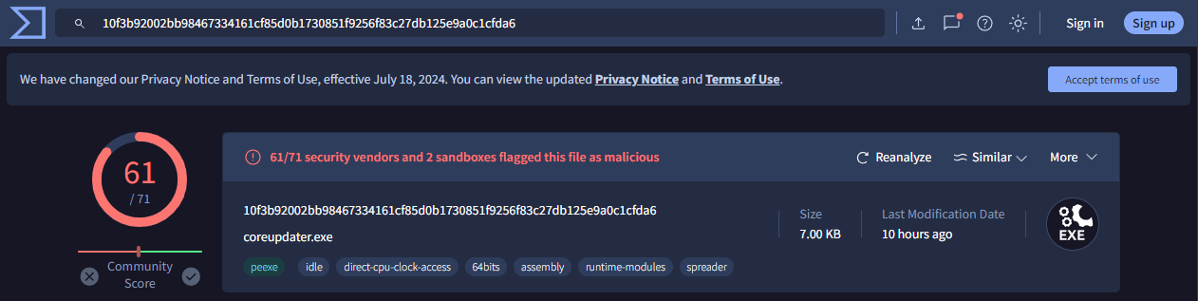

**From Volatility**

* **compupdator.exe** with PID 3644 stands out as potentially suspicious. This name does not correspond to any known standard Windows processes and appears anomalous. The timestamp shows it started at 2020-09-19 03:56:37 UTC+0000 and exited at 2020-09-19 03:56:52 UTC+0000, which could indicate short-lived malicious activity.

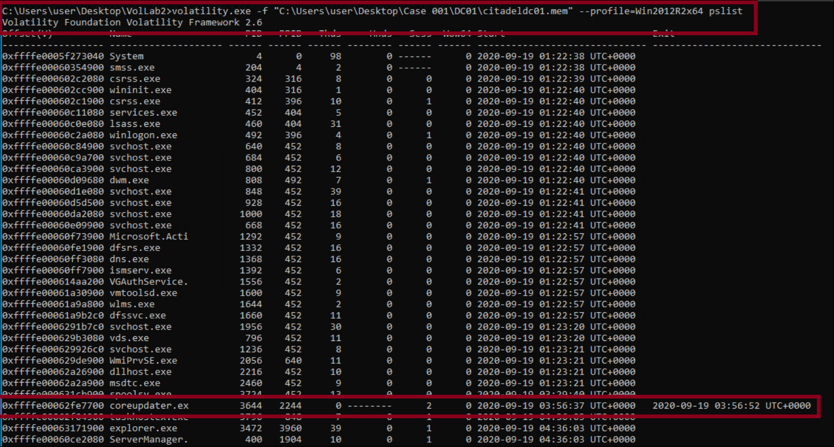

* Confirmed with checking hash value on virus total.

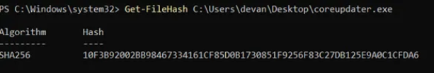

**From Autorus**

* On investigating Autoruns files from the bother server and desktop, I noticed there is only one file with no signatures on it, which also confirms the suspicions.
* Confirmed with checking hash value on virus total. This time checked with the MD5 hash found on autoruns data.
  + **Hash- EED41B4500E473F97C50C7385EF5E374**

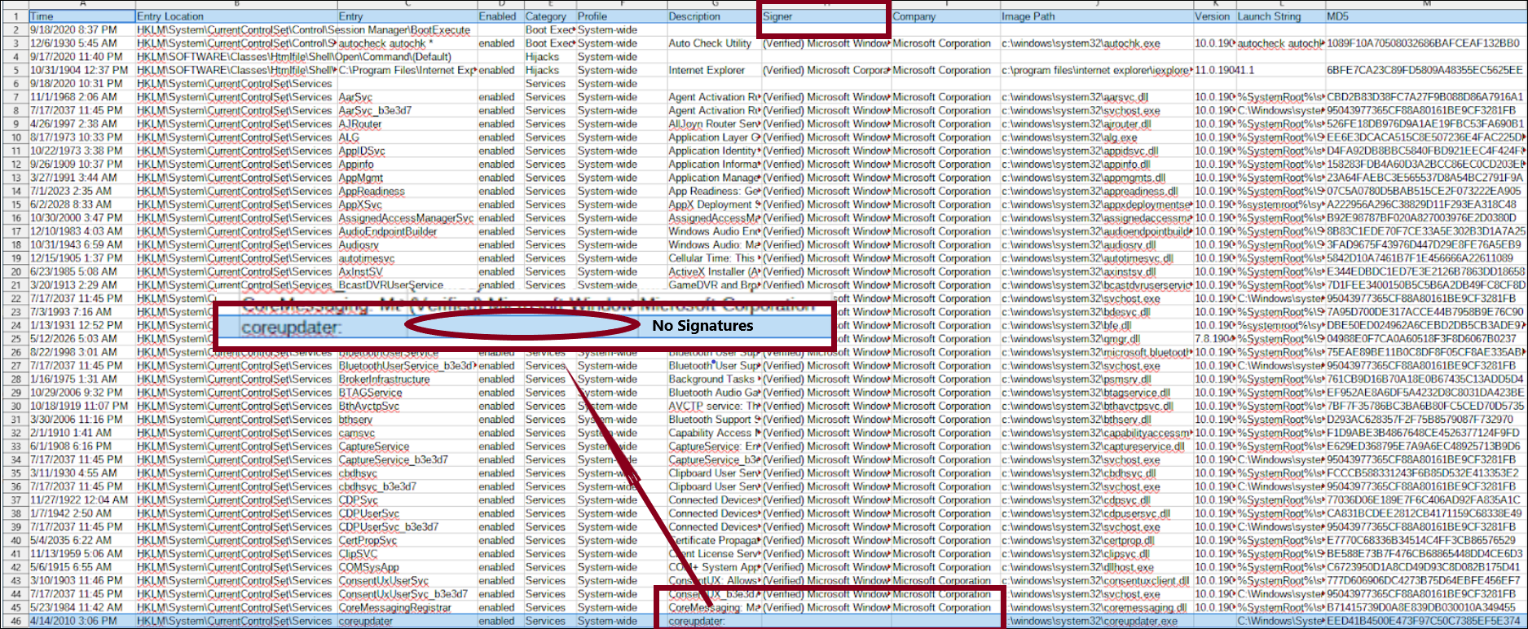

### **6. b What was the IP that delivered the payload?**

**Answer: 194.61.24.102** via Internet Explorer download when the attacker was RDP’d into the victim.

**Autopsy**

* On searching the ***web history*** of Disk Images on Autopsy, I noticed that for almost every request DNS address was used except the 2 direct requests to the IP address, which is unusual.

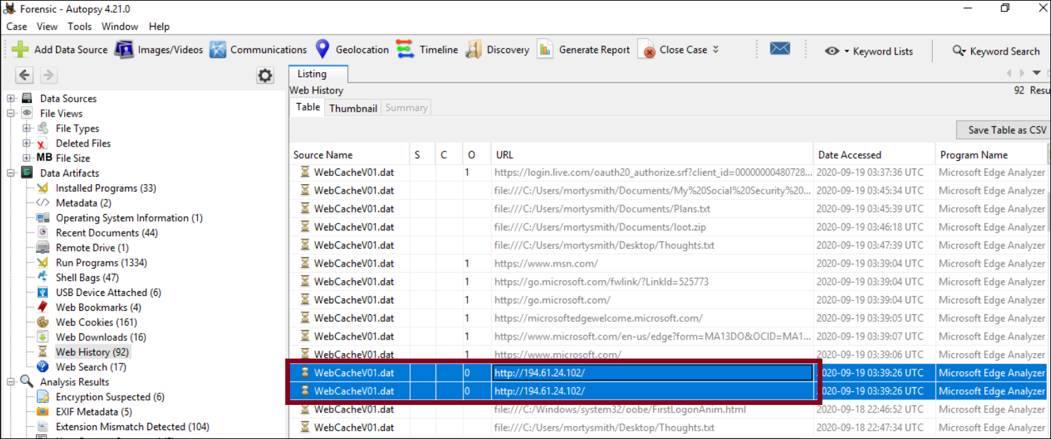

**Wireshark**

To confirm my Suspicion, I checked the IP range on Wireshark and noticed **coreupdater.exe** with the hostname’s IP **194.61.24.102** which is the potential one to deliver the payload.

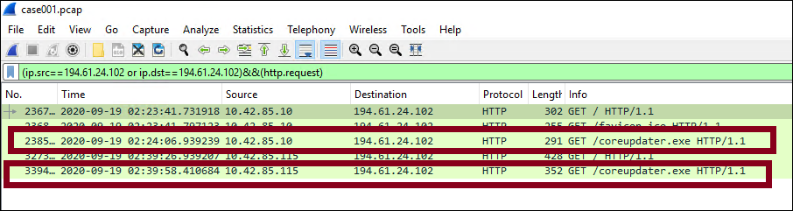

### **6. c. What IP Address is the malware calling to?**

**Answer: 203.78.103.109**

**VirusTotal**

During My initial investigation of the hash value coreupdater.exe file, I noticed 11 IP relations to it out of which 2 were marked suspicious.

* ***203.78.103.109 - Thailand region***
* ***23.216.147.76 - USA***

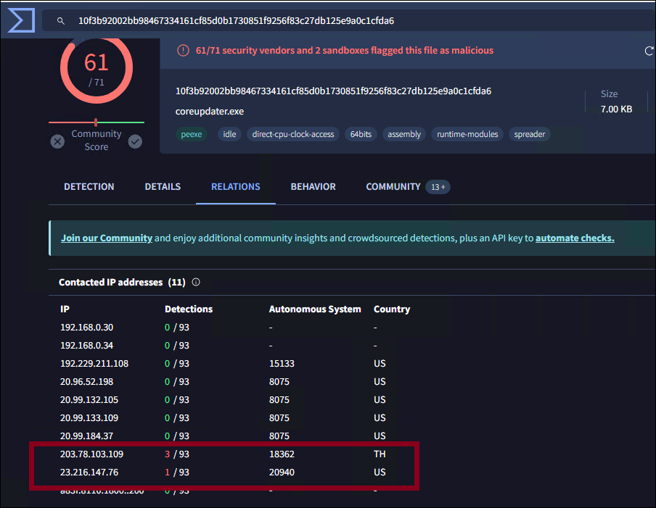

**Wireshark**

To confirm, I checked both Ips in PCAP files and found **203.78.103.109** was the most called IP Address

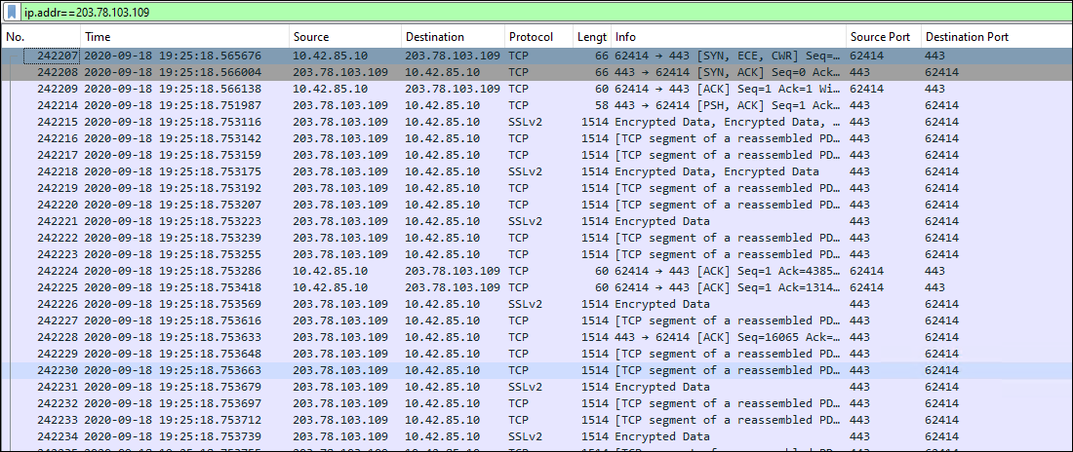

### **6. c. Where is this malware on disk?**

**Answer: C:\Windows\System32\coreupdate.exe**

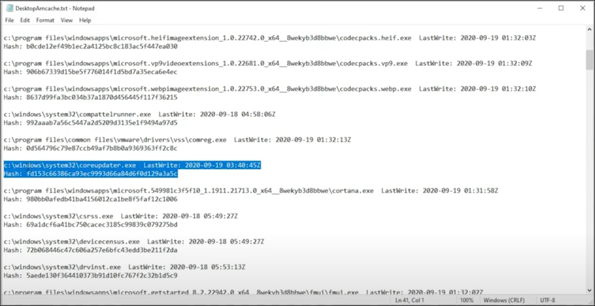

### **6.d. When did it first appear?**

**Answer:** It first appeared on **2020–09–19 03:56:52 UTC+0000**

**Volatility**

Found this information by running plist

* ***volatility -f “path to file” –profile=Win2012R2x64 pslist***



### 

### **6.e. Did someone move it?**

**Answer: Yes**

**Autopsy**

By checking the properties of the Coreupdater.exe file, we noticed different times of creation and modification, which proved that the file was moved.

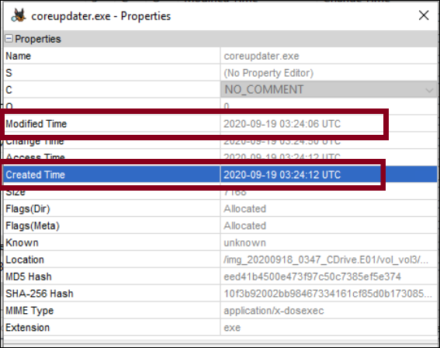

### **6. f. What were the capabilities of this malware?**

**Answer: Threat Type Metasploit**

**VirusTotal**

During our initial malware scan, we found the community identifiers have indicated this to be ***Metasploit***

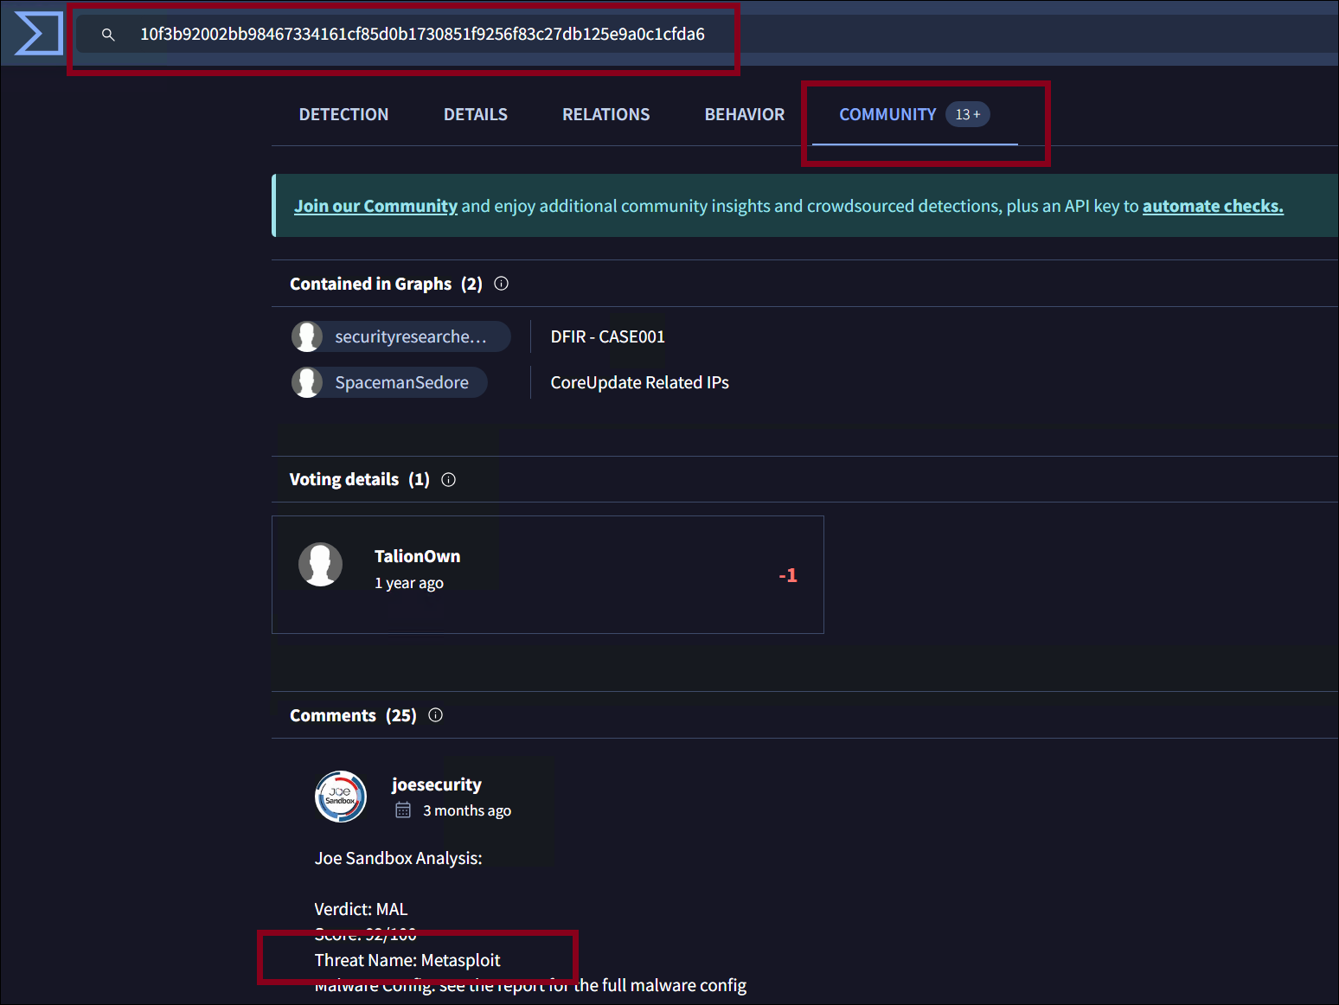

It is capable of

* **Data Exfiltration:** Theft of sensitive data, including passwords or proprietary information.
* **Remote Control:** Allowing the attacker to remotely access and control the compromised machine through a backdoor.
* **File Encryption and Ransom Demand:** Commonly associated with ransomware, where files are encrypted and a ransom is demanded.
* **Propagation:** Spreading to other systems within the network or to external contacts.
* **Destruction:** In some cases, attackers can intentionally damage or completely erase computer systems, causing significant harm.

### **6. g. Is this malware easily obtained?**

**Answer: Metasploit is a red teaming tool that is open source. It comes with the Metasploit Framework.**

### **6. h. Was this malware installed with persistence on any machine?**

Persistence is commonly obtained through scheduled tasks, registry keys, and services. The answer to this is **Yes**, on both Server and Desktop.

### **When?**

**Volatility**

The installation of the service, “core updater”, first occurred on the

* **DC at 3:56:52** ( found from volatility by doing plist)



* **DESKTOP-SDN1RPT at 3:40:49**  ( found from volatility workbench by doing plist)

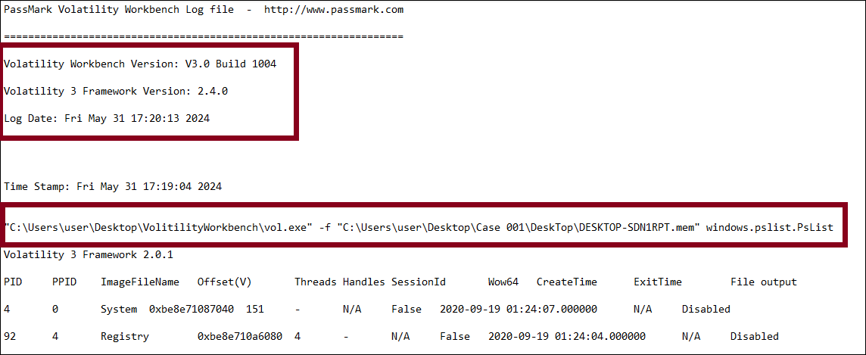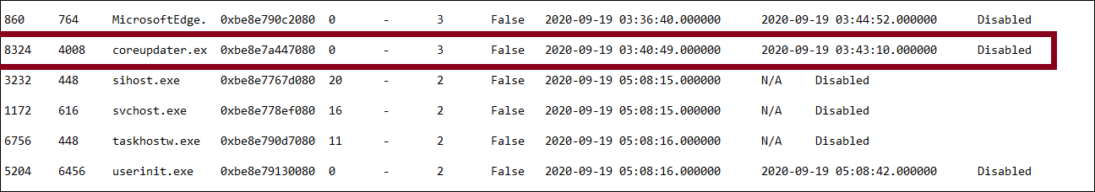

### **Where?**

**Registry Explorer**

By uploading the Service hives from both the DC server and Desktop, we found the malware in Registry Services.

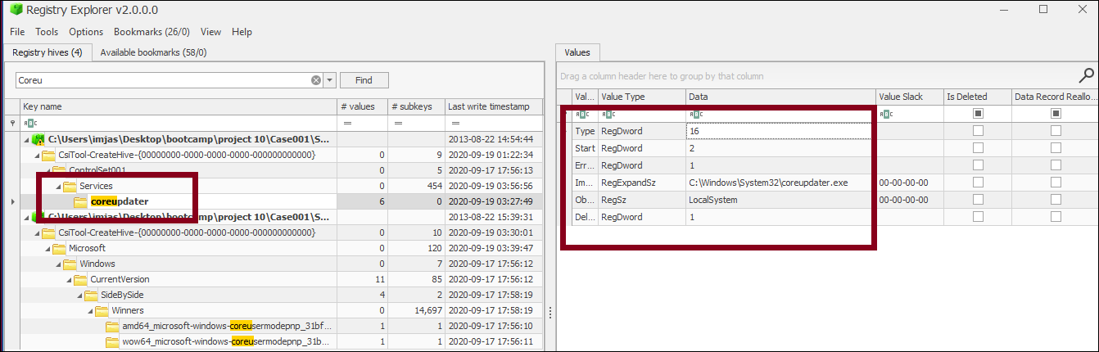

DC server

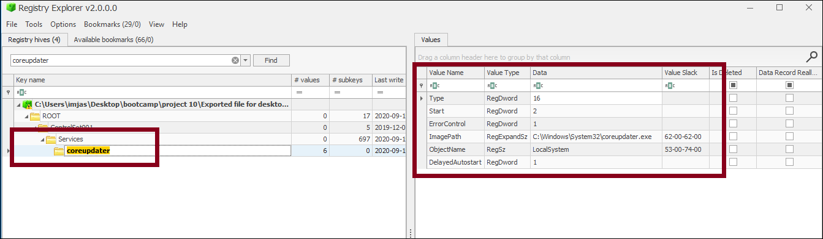

Desktop

## Question 7: What malicious IP Addresses were involved?

**Answer: 194.61.24.102 and 203.78.103.109**

### **7. a. Were any IP Addresses from known adversary infrastructure?**

**Virustotal**

VirusTotal aggregates data from multiple sources and will show these IPs are flagged by many security vendors.

* The IP address 194.61.24.102 has been traced in the past for its use in RDP Brute Force attacks, hence it has been confirmed that it is a part of known adversary infrastructure.
* The IP address 203.78.103.109 was briefly connected to a suspicious website.

### **7. b. Are these pieces of adversary infrastructure involved in other attacks around the time of the attack?**

**Shodan**

**Answer:** Shodan results show historical activities related to IP address **194.61.24.102**.

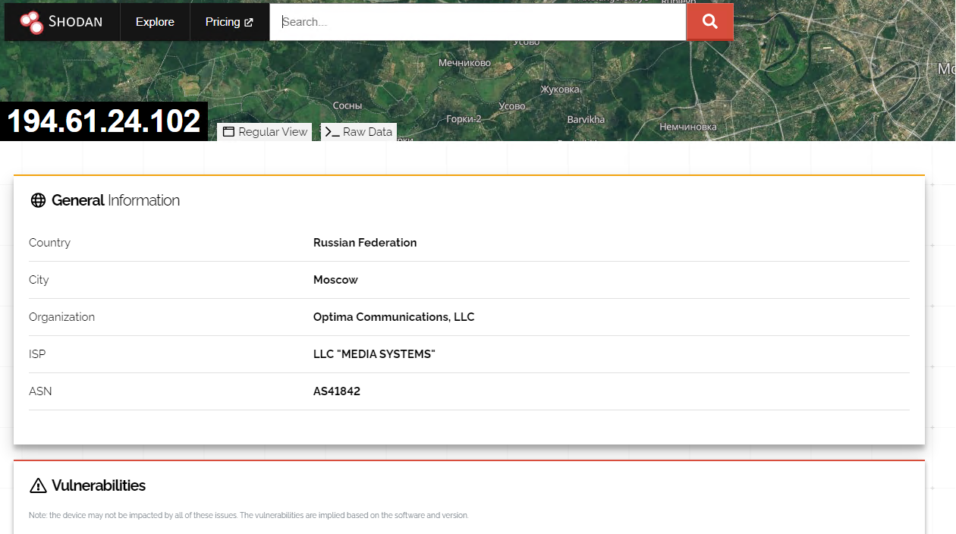

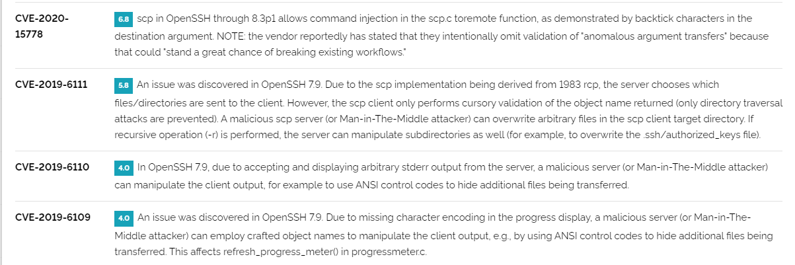

## Question 8: Did the attacker access any other systems? How? When?

**Answer:** The attack managed to enter **DESKTOP-SDN1RPT** by utilizing Remote Desktop Protocol (RDP) from the Domain Controller (DC) while using the Administrator account.

This took place around **2:36 on the 19th**, and we detected this activity within the pcap file.

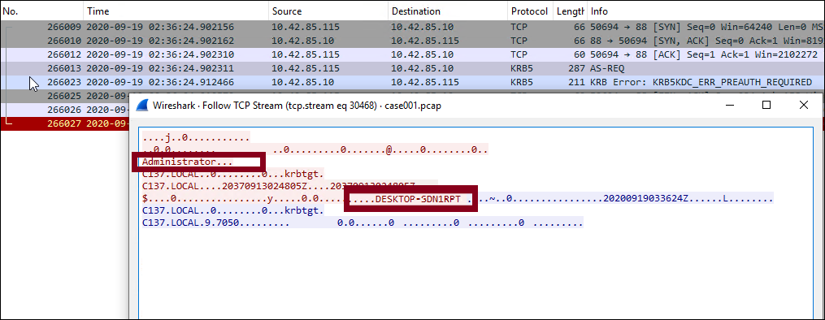

### 

### **8.b. Did the attacker steal or access any data?**

**Answer: Yes**

* **secret.zip** was exfiltrated from the **DC**
* **loot.zip** was exfiltrated from the **Desktop Machine**

**FTK Imager and Autopasy**

* Through FTK Imager, I investigated the Server Image E01 and found the ***Secret folder*** was shared.

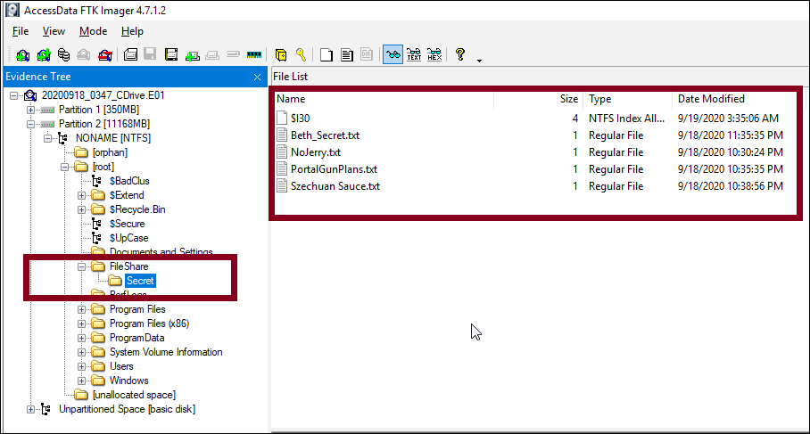

* The Autopsy Image Shared by my Group partner gives proof of file modification

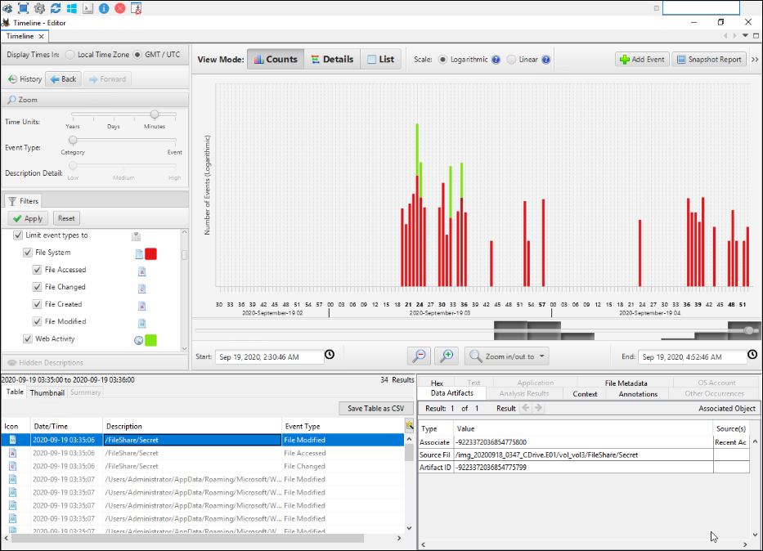

* When exfiltrating data, it is common for a malicious actor will create a staging zip file in which all the stolen data is stored to make the exfiltration a quick process.
* To find out more about that we checked the recent document section of Desktop Image in Autopsy and found proof of a zip file on the desktop called “***loot.zip***”

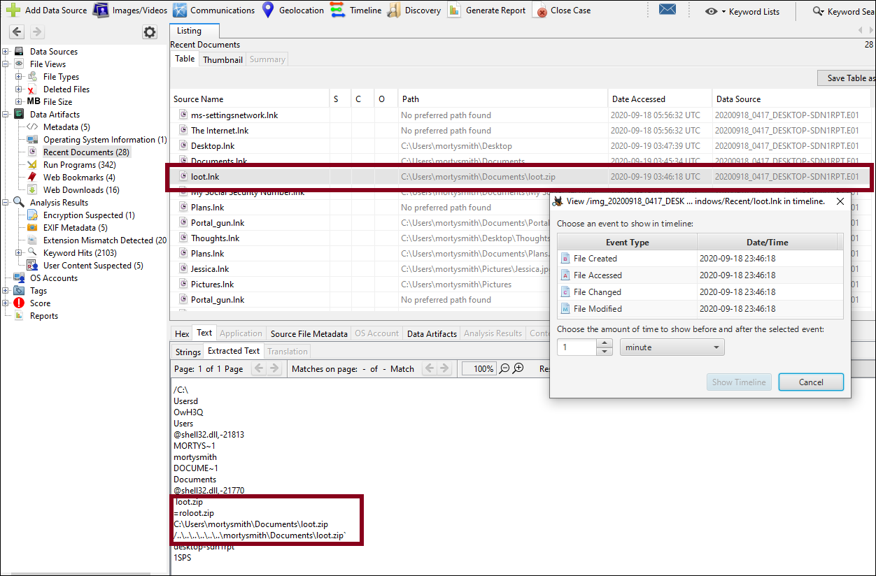

## Question 9: What was the network layout of the victim network?

**Autopsy**

To determine the network configuration of the targeted system, we can examine the autopsy process. By following these steps

* Navigate to: ***System > ControlSet001 > Services > Tcpip > Parameters > Interfaces.*** In this context, it’s observed that two hosts share an identical subnet, specifically **10.42.85.0/24.**
* The two devices on this subnet include a DC with an IP address of **10.42.85.10**

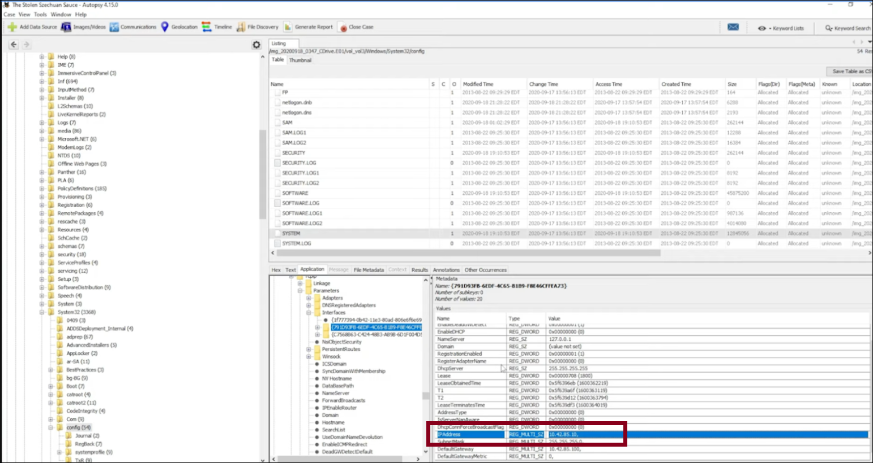

* Desktop computer with an IP address of **10.42.85.115**

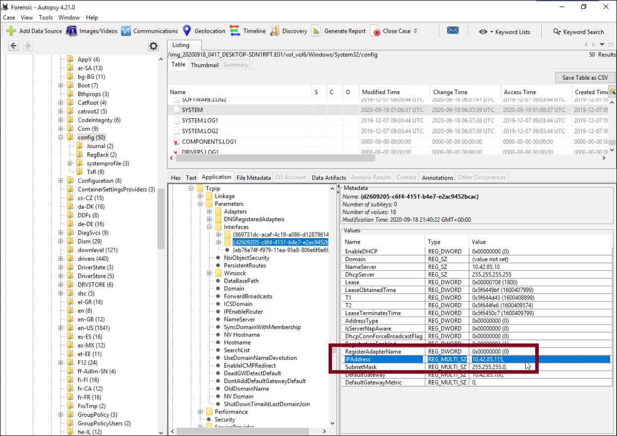

# Bonus Questions

## What architectural changes should be made immediately?

* The ability to RDP to the DC should be immediately removed for external connections given that the first access was achieved through an RDP brute force assault against the DC.
* Only users connected to the same local network should have access to the DC through RDP.

## Did the attacker steal the Szechuan sauce? If so, what time?

**Yes**, the Attacker successfully steeled the sauce recipe. To prove as before, the Secret folder in Autopsy showed the modified date.

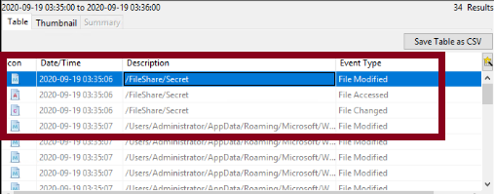

## Did the attacker steal or access any other sensitive files? If so, what times?

**Yes**.

* Apart from the Sauce recipe, the attacker seems to have gotten hold of other data **FileShare** folder. The image shows the files along with the modified date.



* Also In FTK Imager, we can view the recycle bin of the DC to confirm its removal and modification of data.

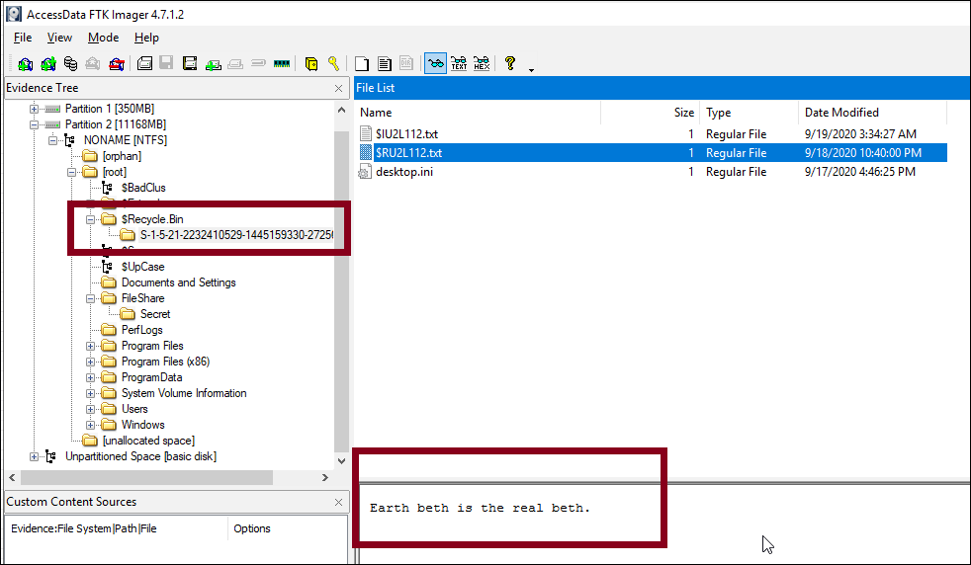

Original File

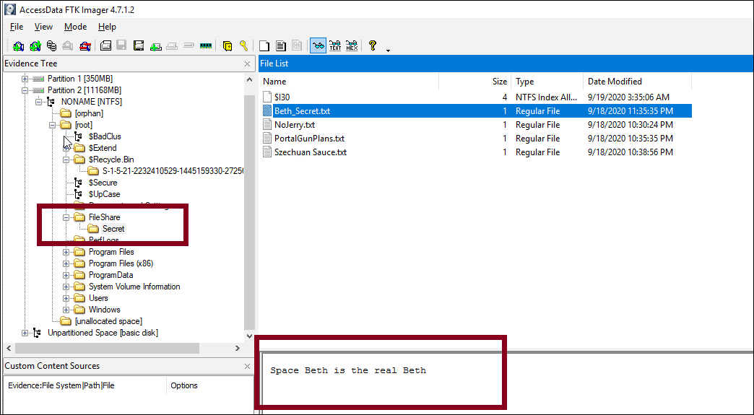

Modified File

# Conclusion

In conclusion, our comprehensive investigation into the "Case of the Stolen Szechuan Sauce" revealed that the breach was facilitated through a brute force attack on RDP, leading to the installation of Metasploit-based malware on both the server and desktop. This malware, coreupdater.exe, enabled data exfiltration and remote control, resulting in the theft of sensitive files.

By identifying key attack vectors, malware activities, and network vulnerabilities, we have provided a set of robust recommendations including restricting RDP access, enforcing strong password policies, and implementing advanced threat detection and network segmentation to prevent future breaches and safeguard the organization's assets.

# 

# References

1. Basis Technology. (2023, December 20). *Autopsy - digital forensics*. Autopsy. <https://www.autopsy.com/>
2. DFIR Madness. (n.d.). *DFIR madness*. <http://dfirmadness.com/>
3. *FTK Imager - Forensic Data Imaging and Preview Solution | Exterro*. (2024, April 4). Exterro. <https://www.exterro.com/digital-forensics-software/ftk-imager>
4. James. (2021, March 25). *Case 001 – The stolen Szechuan Sauce*. DFIR Madness. <https://dfirmadness.com/the-stolen-szechuan-sauce/>
5. Markdefalco. (n.d.). *Event viewer*. Microsoft Learn. <https://learn.microsoft.com/en-us/shows/inside/event-viewer>
6. *MDwiki*. (n.d.). <https://ericzimmerman.github.io/#!index.md>
7. *Shodan*. (n.d.). Shodan. <https://www.shodan.io/>
8. The Volatility Foundation. (2024, April 10). *Home of the Volatility Foundation | Volatility Memory Forensics - The Volatility Foundation - Promoting accessible memory analysis tools within the memory Forensics community*. The Volatility Foundation - Promoting Accessible Memory Analysis Tools Within the Memory Forensics Community. <https://volatilityfoundation.org/>
9. *VirusTotal*. (n.d.). VirusTotal. <https://www.virustotal.com/>
10. *Wireshark · Go Deep*. (n.d.). Wireshark. <https://www.wireshark.org/>